

application layer

Introduction to Networking and Security



November 24, 2019

Jamie lu

W0441213

Table of Contents

Introduction: 3

Question 3 4

Activity 10.2.1.7 4

*SCREENSHOT 1 OF ACTIVITY 10.2.1.7 COMPLETION* 4

*SCREENSHOT 2 OF ACTIVITY 10.2.1.7 COMPLETION* 5

*SCREENSHOT 3 OF ACTIVITY 10.2.1.7 COMPLETION* 6

Question 4 7

Activity 10.2.2.7 7

*SCREENSHOT 1 OF ACTIVITY 10.2.2.7 COMPLETION* 7

*SCREENSHOT 2 OF ACTIVITY 10.2.2.7 COMPLETION* 8

*SCREENSHOT 3 OF ACTIVITY 10.2.2.7 COMPLETION* 9

Question 5 10

Activity 10.2.3.3 10

*SCREENSHOT 1 OF ACTIVITY 10.2.3.3 COMPLETION* 10

*SCREENSHOT 2 OF ACTIVITY 10.2.3.3 COMPLETION* 11

*SCREENSHOT 3 OF ACTIVITY 10.2.3.3 COMPLETION* 12

Question 6 13

Activity 10.3.1.4 13

CLIENT-SIDE COMPLETION: 13

*SCREENSHOT 1 OF CLIENT-SIDE COMPLETION* 13

*SCREENSHOT 2 OF CLIENT-SIDE COMPLETION* 14

*SCREENSHOT 3 OF CLIENT-SIDE COMPLETION* 15

SERVER-SIDE COMPLETION: 16

*SCREENSHOT 1 OF SERVER-SIDE COMPLETION* 16

*SCREENSHOT 2 OF SERVER-SIDE COMPLETION* 17

*SCREENSHOT 3 OF SERVER-SIDE COMPLETION* 18

Question 14 19

SCREENSHOT OF WORKGROUP AND ETHERNET 19

Question 16 19

SCREENSHOT OF WORKGROUP AND ETHERNET 19

Question 26 20

SCREENSHOT OF THREEWAY HANDSHAKE 20

b. SYN-ACK Capture: 21

SCREENSHOT OF SYN-ACK CAPTURE 21

c. ACK Capture 22

SCREENSHOT OF ACK CAPTURE 22

d. Client Hello Capture 23

SCREENSHOT OF CLIENT HELLO CAPTURE SESSION ID 23

SCREENSHOT OF CLIENT HELLO 24

d. Get /index.html capture data 25

SCREENSHOT OF GET /INDEX.HTML CAPTURE DATA 25

SCREENSHOT OF GET /INDEX.HTML CAPTURE DATA 26

Question 27: Website 27

SCREENSHOT OF WEBSITE FROM THE DESKTOP 27

SCREENSHOT OF WEBSITE FROM THE SERVER 27

References 28

Appendix 29

Appendix A – Cisco Commands Tool Kit 29

# Introduction:

This assignment contains activities that used learnings from Cisco’s CCNA R&S: Introduction to Networking: Chapters 10[1]. This assignment also contains the continued information learned and skills acquired with regards to the topics that were covered in previous chapters and in Chapter 10, The Application Layer, it’s software, services and protocol. It also covers servers, remote access (such as VPNs, encryption and authentication), web and email, virtualization, and cloud-based storage. It also shows the knowledge and skills that are needed in order to setup an HTML server.

# Question 3

## Activity 10.2.1.7

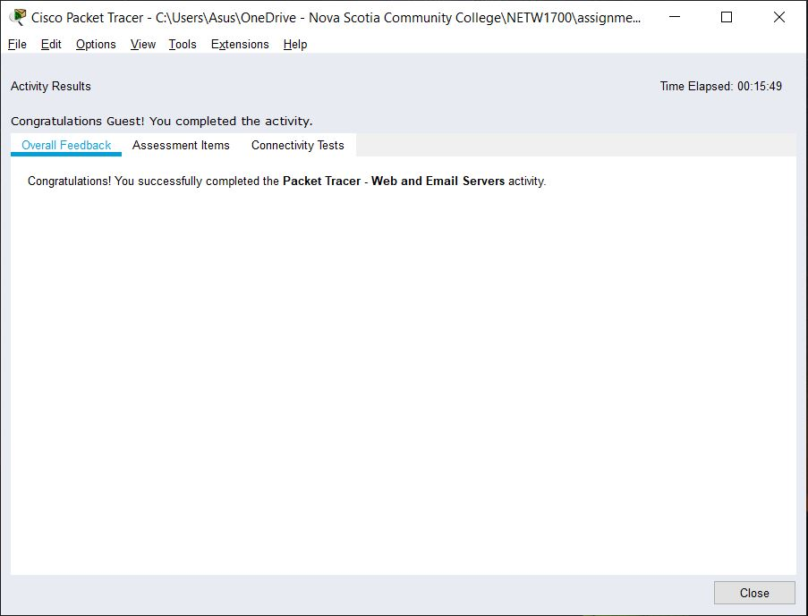

#### SCREENSHOT 1 OF ACTIVITY 10.2.1.7 COMPLETION

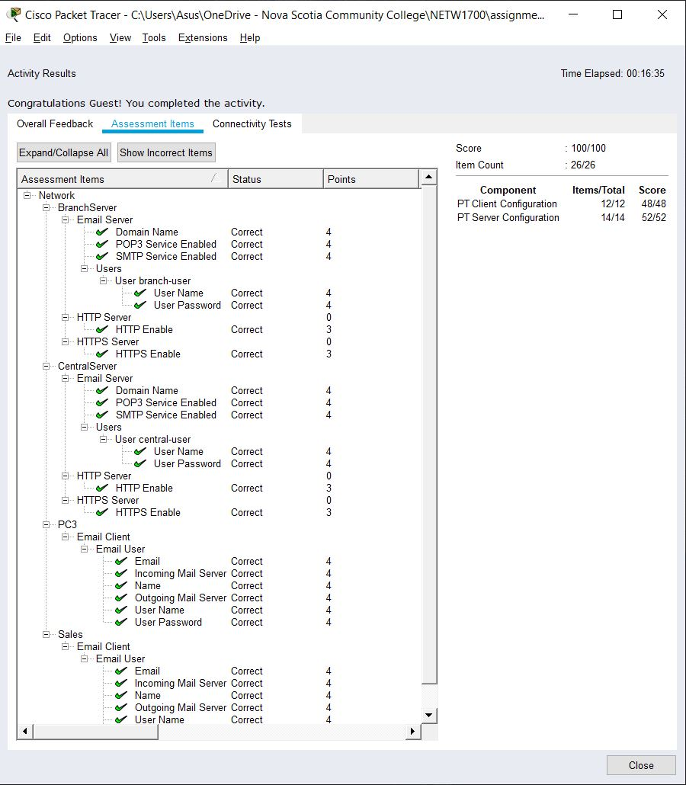

#### SCREENSHOT 2 OF ACTIVITY 10.2.1.7 COMPLETION

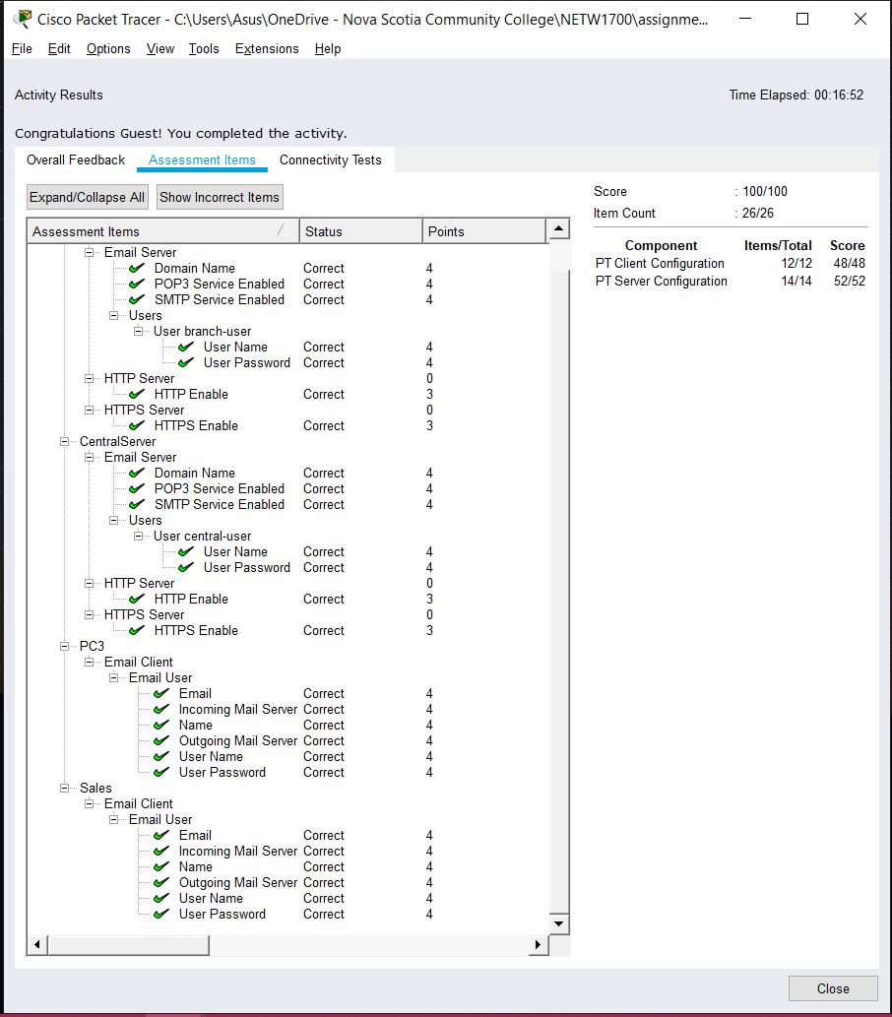

#### SCREENSHOT 3 OF ACTIVITY 10.2.1.7 COMPLETION

# Question 4

## Activity 10.2.2.7

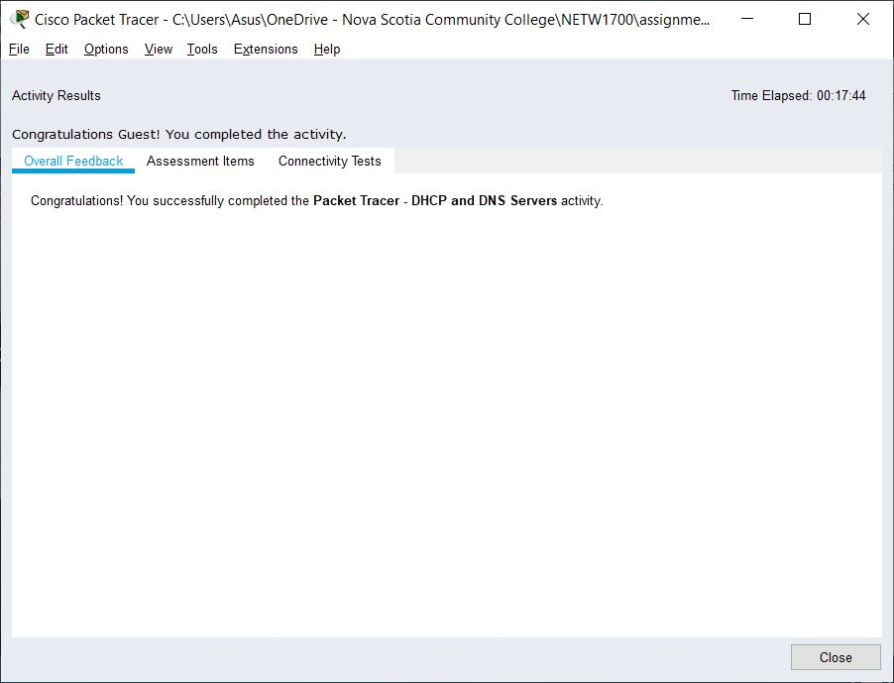

#### SCREENSHOT 1 OF ACTIVITY 10.2.2.7 COMPLETION

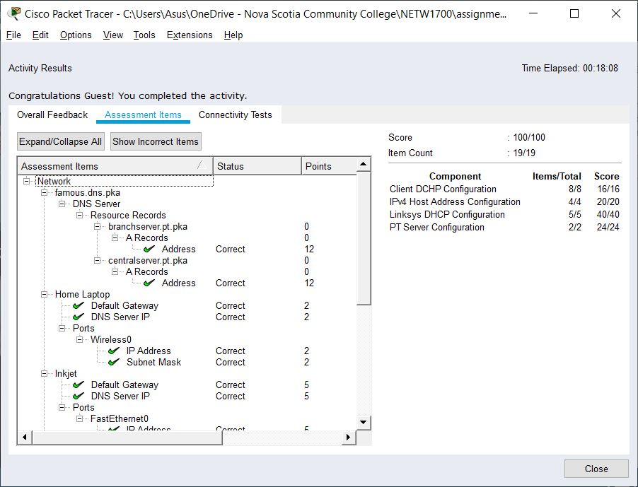

#### SCREENSHOT 2 OF ACTIVITY 10.2.2.7 COMPLETION

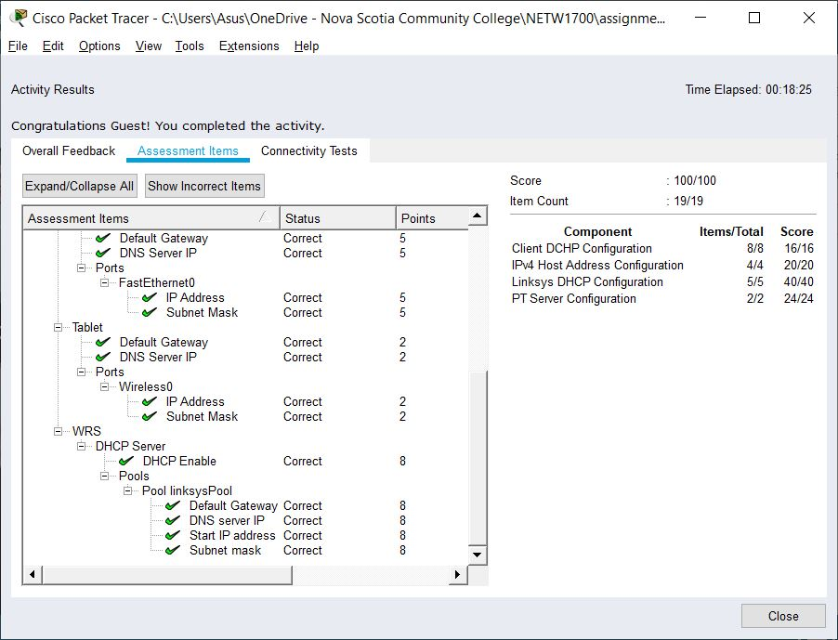

#### SCREENSHOT 3 OF ACTIVITY 10.2.2.7 COMPLETION

# Question 5

## Activity 10.2.3.3

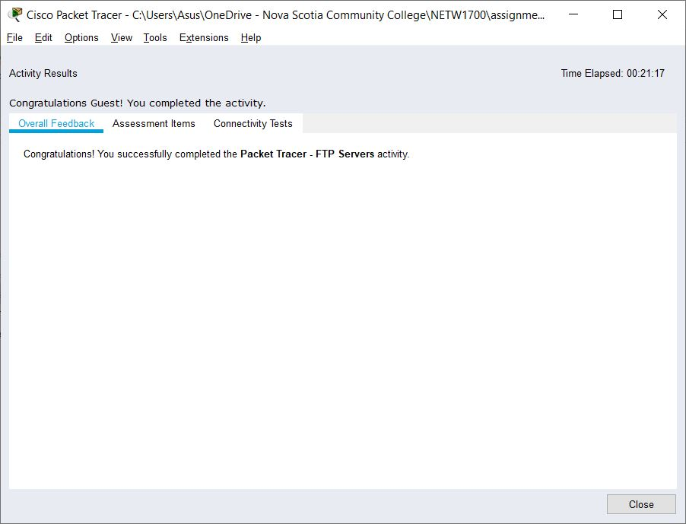

#### SCREENSHOT 1 OF ACTIVITY 10.2.3.3 COMPLETION

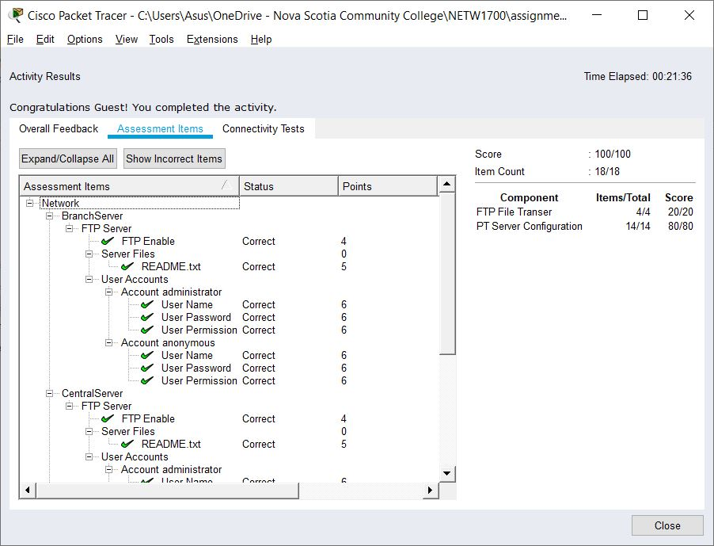

#### SCREENSHOT 2 OF ACTIVITY 10.2.3.3 COMPLETION

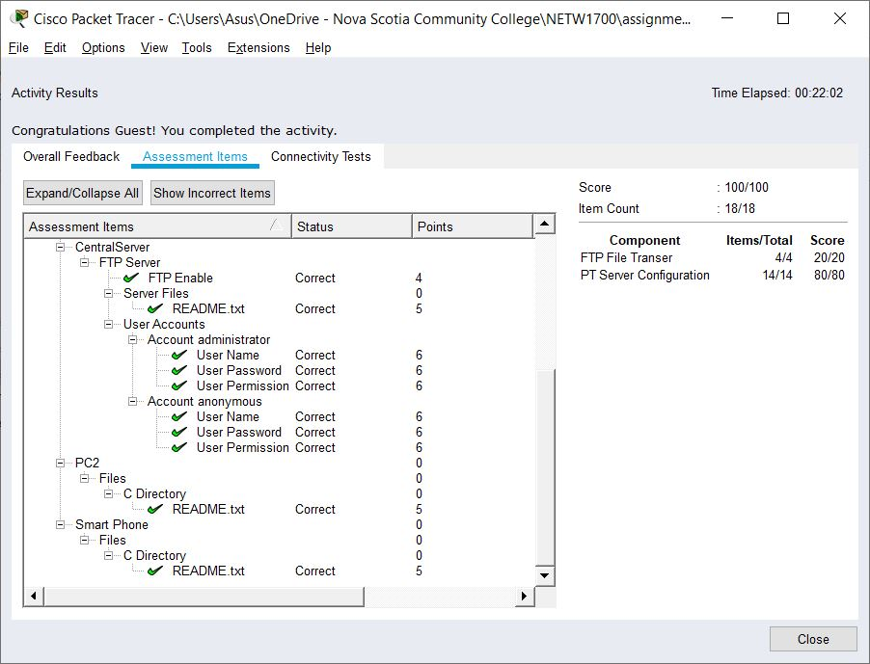

#### SCREENSHOT 3 OF ACTIVITY 10.2.3.3 COMPLETION

# Question 6

## Activity 10.3.1.4

## CLIENT-SIDE COMPLETION:

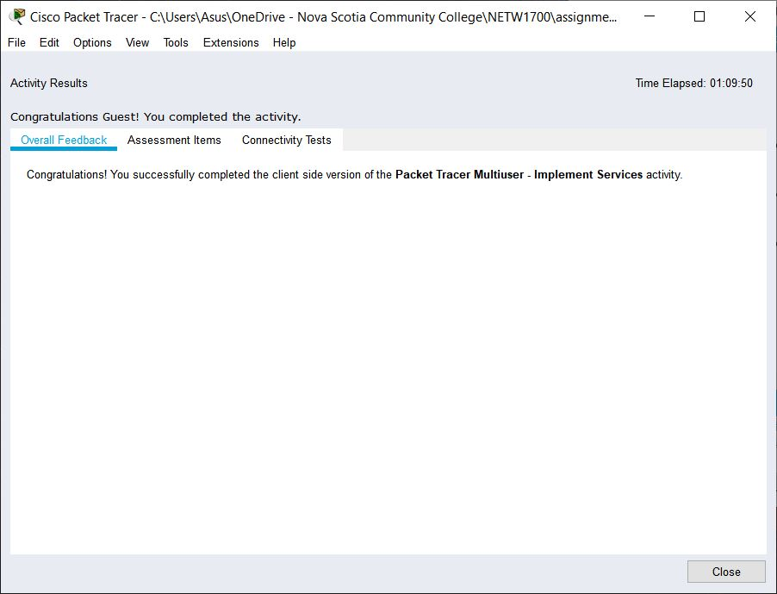

#### SCREENSHOT 1 OF CLIENT-SIDE COMPLETION

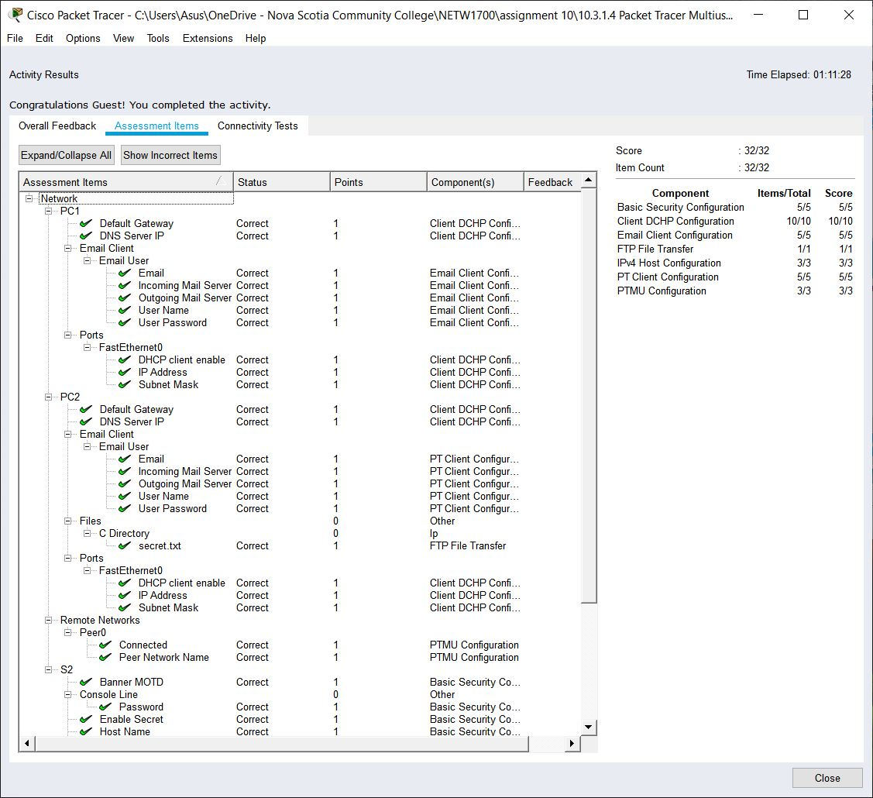

#### SCREENSHOT 2 OF CLIENT-SIDE COMPLETION

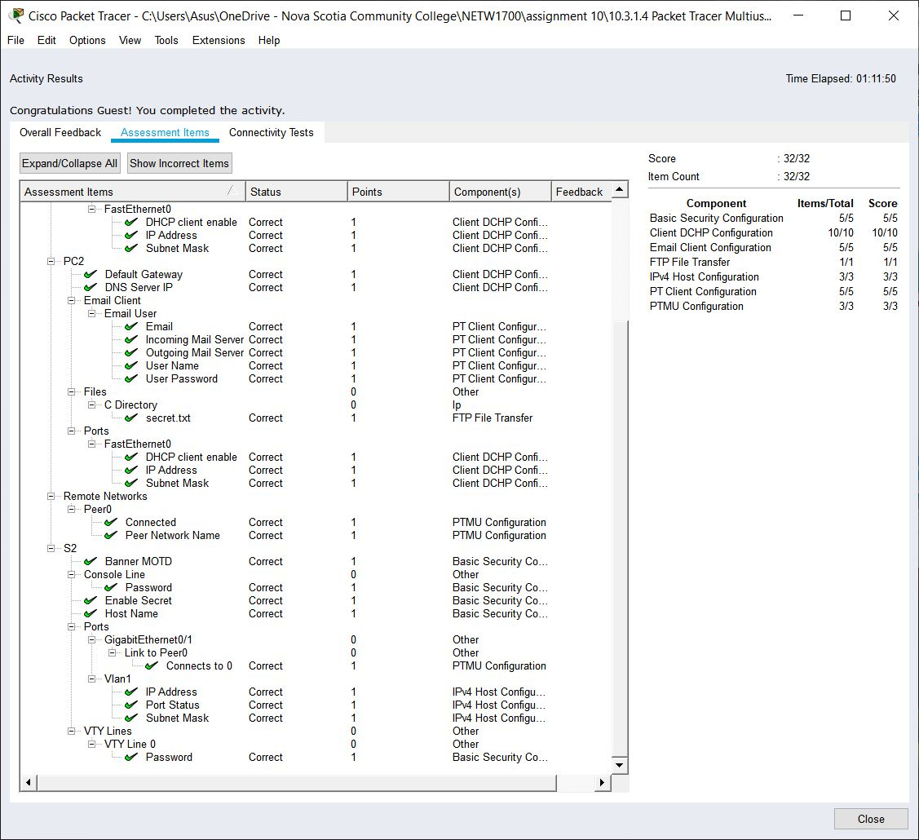

#### SCREENSHOT 3 OF CLIENT-SIDE COMPLETION

## SERVER-SIDE COMPLETION:

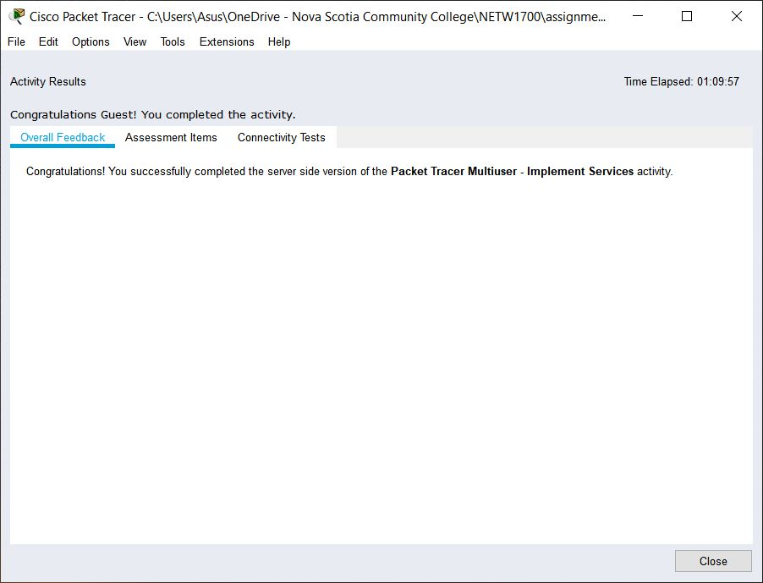

#### SCREENSHOT 1 OF SERVER-SIDE COMPLETION

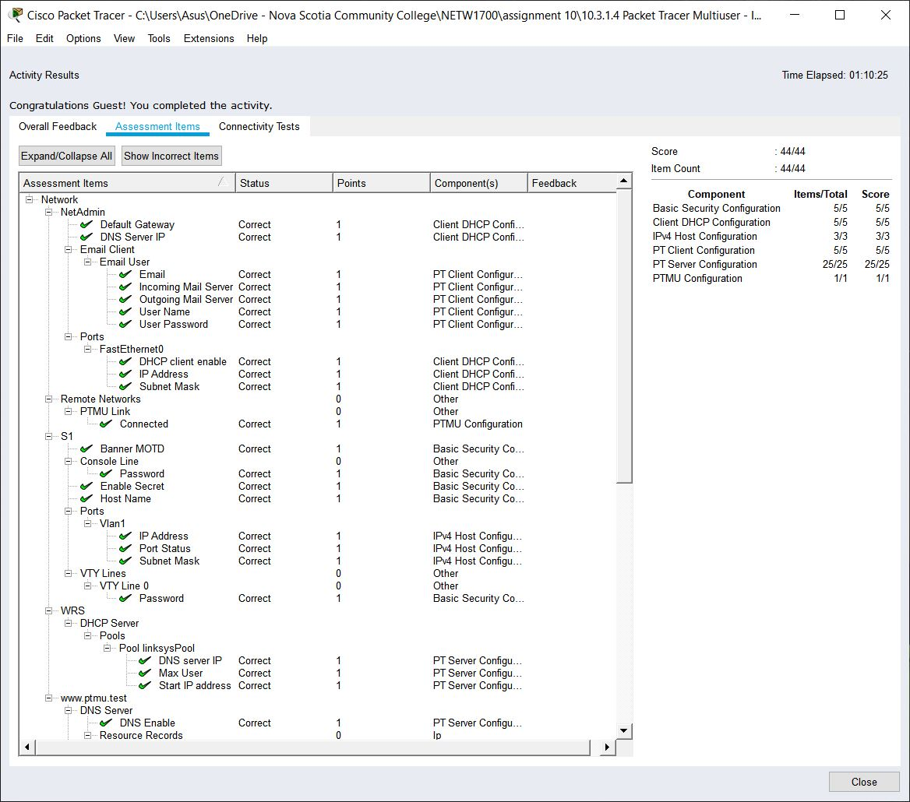

#### SCREENSHOT 2 OF SERVER-SIDE COMPLETION

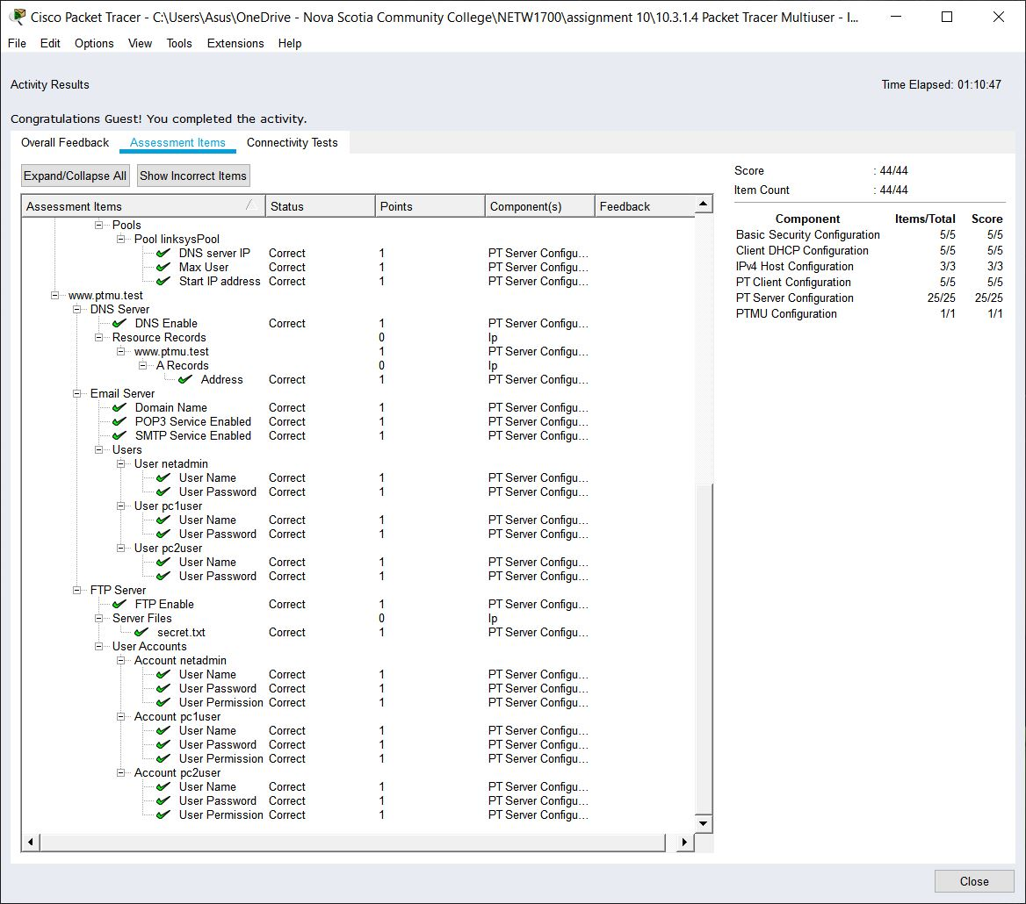

#### SCREENSHOT 3 OF SERVER-SIDE COMPLETION

# Question 14

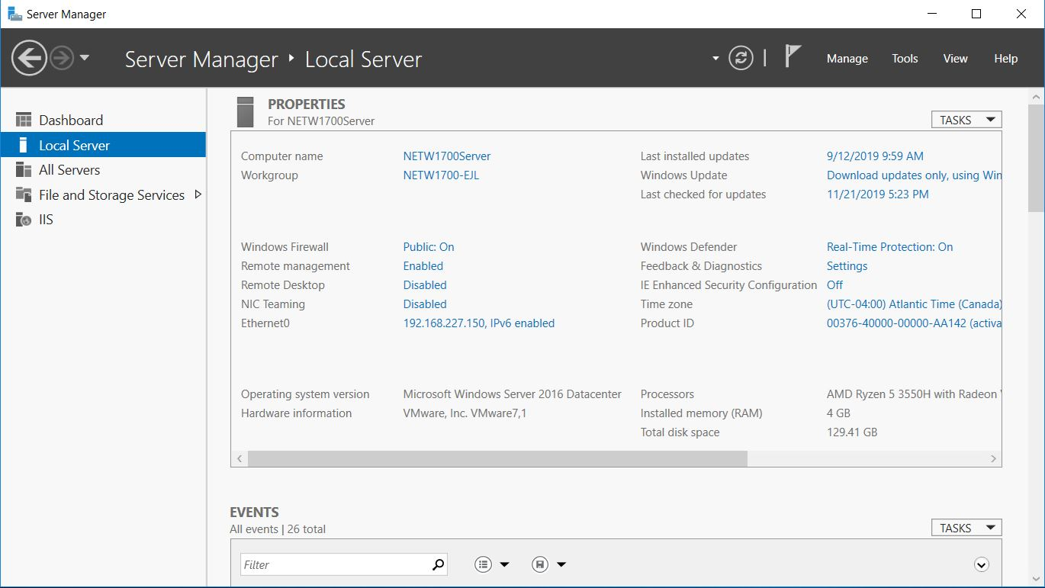

### SCREENSHOT OF WORKGROUP AND ETHERNET

# Question 16

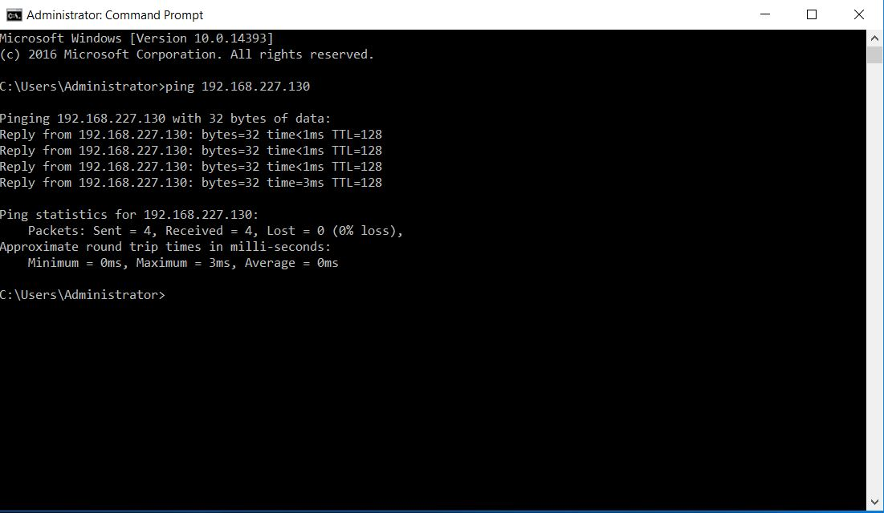

### SCREENSHOT OF WORKGROUP AND ETHERNET

# Question 26

a. Three Way Handshake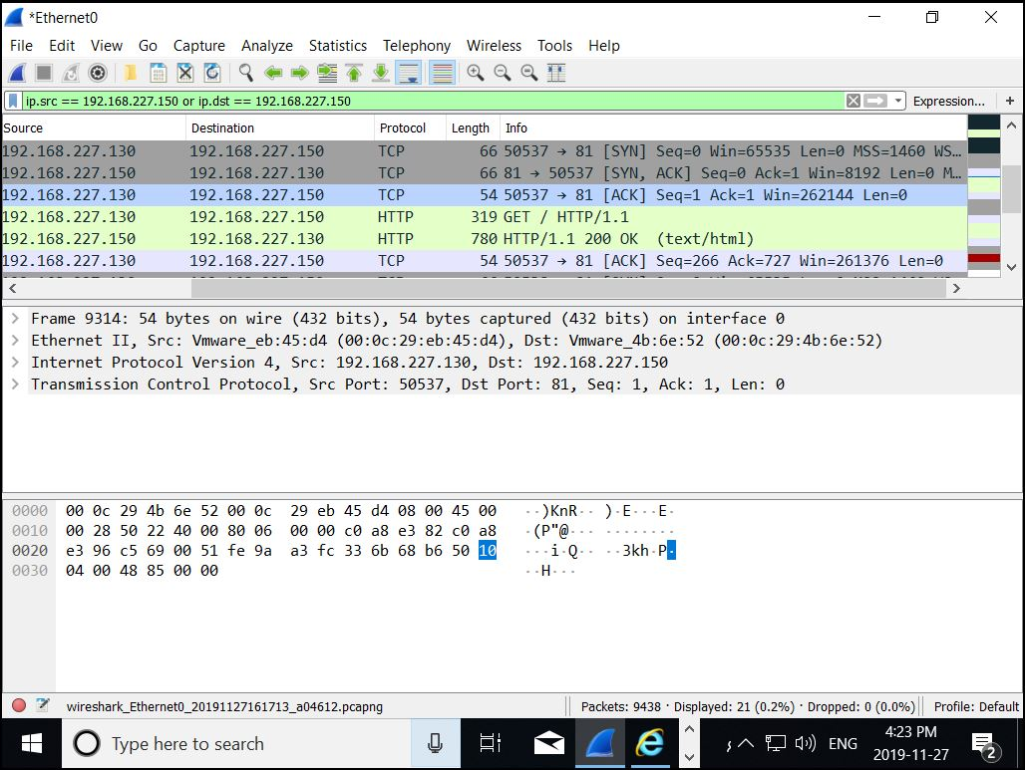

### SCREENSHOT OF THREEWAY HANDSHAKE

## b. SYN-ACK Capture:

Source Port: 81

Sequence Number: 0

Acknowledgement Number: 1

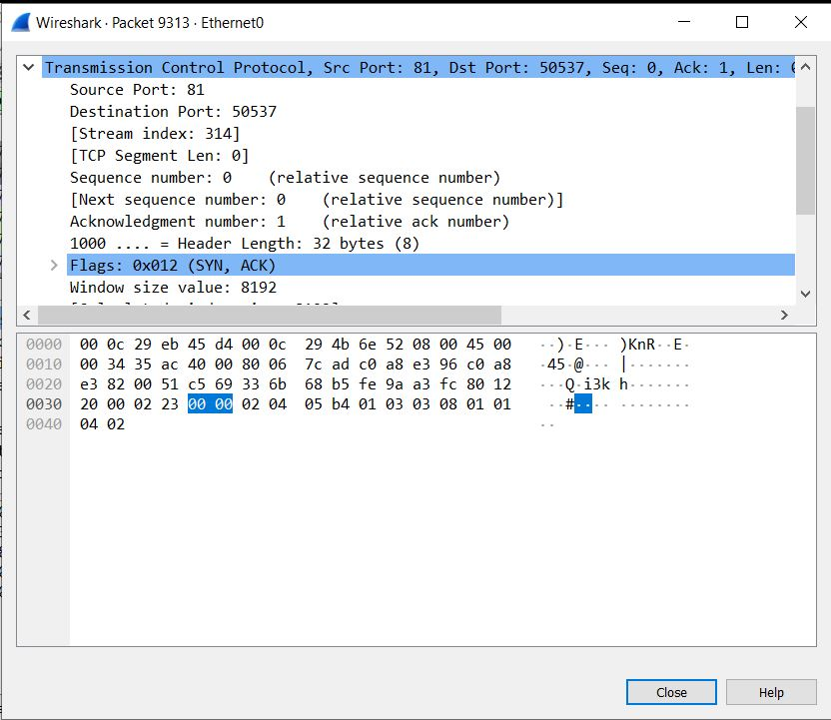

### SCREENSHOT OF SYN-ACK CAPTURE

## c. ACK Capture

Source MAC Address: 00:0c:29:eb:45:d4

Destination MAC Address: 00:0c:29:4b:6e:52

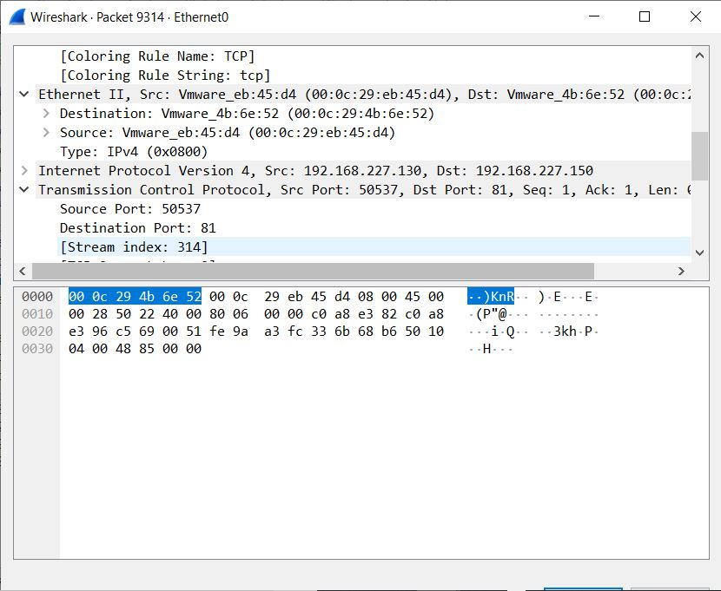

### SCREENSHOT OF ACK CAPTURE

## d. Client Hello Capture

Session ID: 2a4b0000d0a8e77b39be64c550775c158333e7afa7ca7e0c…

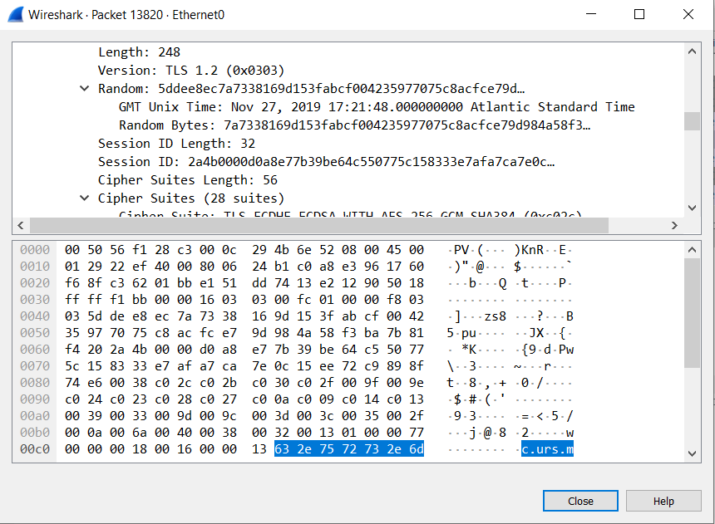

### SCREENSHOT OF CLIENT HELLO CAPTURE SESSION ID

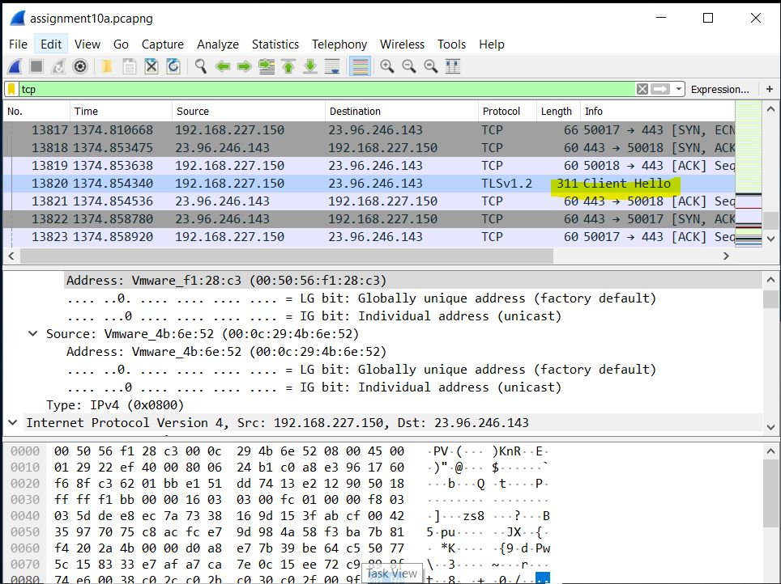

### SCREENSHOT OF CLIENT HELLO

## d. Get /index.html capture data

Protocol used: HTTP

Arrival Time: Nov 27, 2019 17:19:07.960921000 Atlantic Standard Time

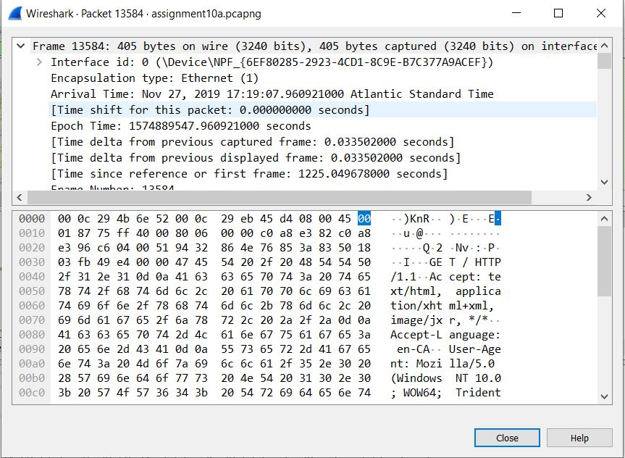

### SCREENSHOT OF GET /INDEX.HTML CAPTURE DATA

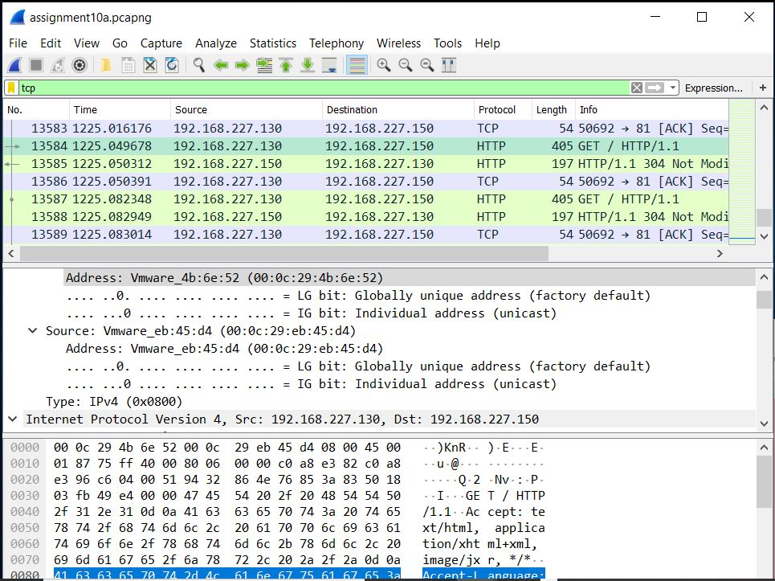

### SCREENSHOT OF GET /INDEX.HTML CAPTURE DATA

## Question 27: Website

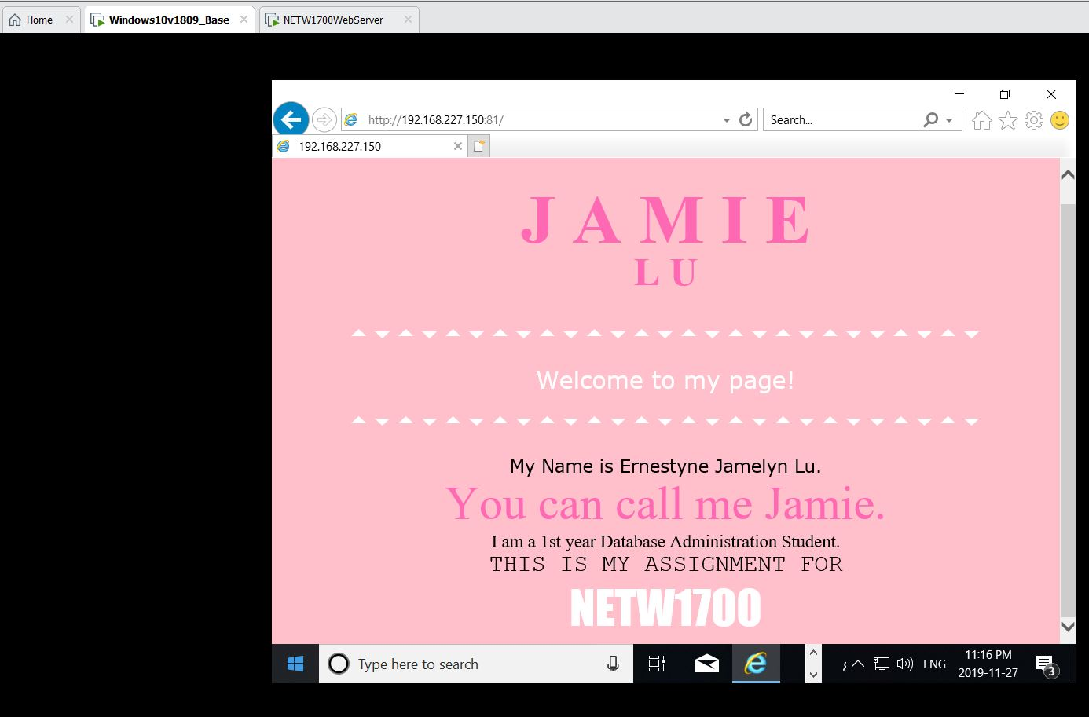

### SCREENSHOT OF WEBSITE FROM THE DESKTOP

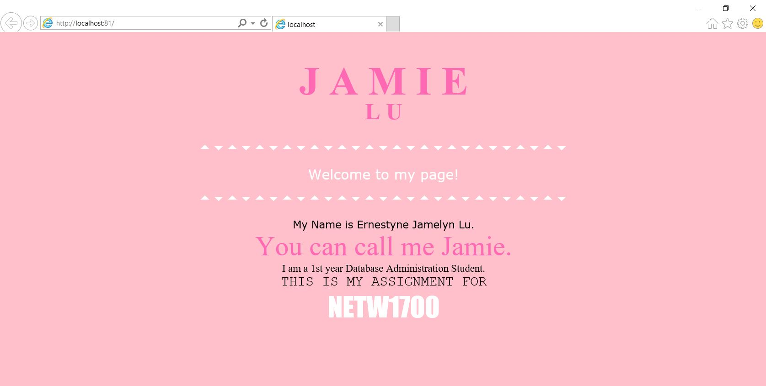

### SCREENSHOT OF WEBSITE FROM THE SERVER

# References

Cisco. (n.d.). *Chapter: Configuring Static Routing*. Retrieved November 15, 2019, from Cisco: https://www.cisco.com/c/en/us/td/docs/switches/datacenter/nexus3000/sw/unicast/503_u1_2/nexus3000_unicast_config_gd_503_u1_2/l3_route.html

Cisco Networking Academy. (n.d.). *Introduction to Networks, Chapter 9: Transport Layer*. Retrieved November 16, 2019, from Cisco Networking Academy: https://static-course-assets.s3.amazonaws.com/ITN6/en/index.html#2

Cisco Systems, Inc. (2010, April). *Cisco IOS Configuration Fundamentals*. Retrieved from Cisco: https://www.cisco.com/c/en/us/td/docs/ios/fundamentals/command/reference/cf_book.pdf

# 

# Appendix

## Appendix A – Cisco Commands Tool Kit[2]

**?** – this command will show the list of all the commands available for the specific mode you are currently in.

**(characters) ?** – this command is known as context-sensitive help. it will show the available commands in the current mode with the specific first characters you have entered. (example: **te?** in the user exec mode will show **te**lnet and **te**rminal, both starting with **te**.)

**banner motd “ ”** – this command will configure the message-of-the-day banner that will display when a user logs in to the switch.

**clock rate (rate)** – this command is used in DCE in serial link. This command configures the clock speed for the ink

**clock set (time and date)** – this command will allow you to set the time and date. (example: **clock set 15:00:00 july 11 2019)**

**copy startup-config flash –** this command will save the startup configuration to the flash memory. The flash memory is good to use as a back up.

**copy running-config startup-config** – this command will save the running configuration to the startup configuration.

**config terminal** – this command will open the global configuration mode.

**description Link to (server name)** – to describe the interface of the specified server.

**enable** – this command will open the privileged exec mode and will give additional commands.

**enable password** – this command followed by a password will set that same password for the privileged exec mode.

**enable secret** – this command followed by a password will set an ***encrypted*** password for the privileged exec mode.

**exit** – this command will exit the current mode.

**Flash –** this command will boot the router from Flash memory

**ip default-gateway –** this command will set the default gateway

**hostname** – this command followed by the name you want the hostname to be will change the hostname to what you want it to be.

**interface** – followed by the interface you want to configure will open that specific interface’s configuration mode.

EXAMPLES:

**interface fa0/0** - enter interface configuration mode for the FastEthernet interface

**interface s0/0/0** – enter interface configuration mode for the serial interface

**interface vlan <1-4094>**– you can use this command to configure an svi on a switch.

**ip address ­**– this command followed by the ip address and subnet mask you want will set the ip address and subnet mask to the entered values.

**ip route {ip-prefix | ip-addr ip-mask} {[next-hop | nh-prefix] | [interface next-hop | nh-prefix]} [tag tag-value [pref]][3] –** this command configures a static route and the interface for the static route.

EXAMPLE:

switch(config)# ip route 192.0.2.0/8 ethernet 1/2 192.0.2.4

switch(config)# ip route 192.0.2.0/8 192.0.2.10

**ipv6 unicast-routing –** in global configuration mode, this command will enable the router to forward IPv6 packets

**ipv6 address <ipv6 address> -** this command will manually assign a specific ipv6 address to an interface. Used in interface configuration mode. Insert no before ipv6 address to remove the address from an interface.

**ipv6 address <link local address> link-local-** this command manually assigns a specific link-local address to an interface and enables IPv6 processing on an interface. Used in interface configuration mode. Insert no before ipv6 address to remove the address from an interface.

**line** – this command will configure a terminal line.

**line console 0** – this command will open the line console configuration mode.

**line vty 0 15** – this command will open the virtual terminal configuration mode.

**login** – this command will enable password checking

**no shutdown** – this command enables an interface.

**password** – this command will set a password.

**ping** – this command will send a request to the destination and wait for the response. this is good for checking network connectivity.

**service password-encryption** – this command in the global config mode will encrypt all unencrypted passwords in the configuration file.

**show interface** – this command will display the status of the interfaces.

**show ip interface** – this command will display the configuration and status of the ip protocol.

**show ip interface brief** – this command gives a summary of the status and IP addresses of the interfaces

**show ip static-route[4] –** this command will display information about the static routes

**Show flash –** this command will show the files on the flash memory.

**show running-config –** this command will show the running configuration

**show startup-config** – this command will show all the startup configuration file.

**show clock** – this command will show the time and date.

***show?*** – this command would show all the show commands in the specific mode you are currently in.

1. (Cisco Networking Academy, n.d.)
2. References and sources from (Cisco Systems, Inc., 2010)
3. Referenced from: (Cisco, n.d.)
4. Referenced from: (Cisco, n.d.)